Cover Letter Rubric
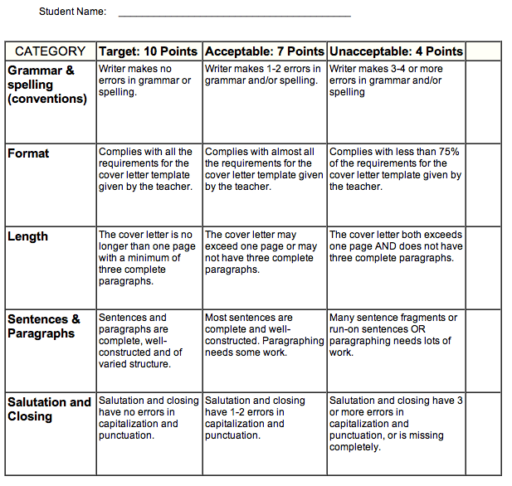

Total: ______________ / 50 points

