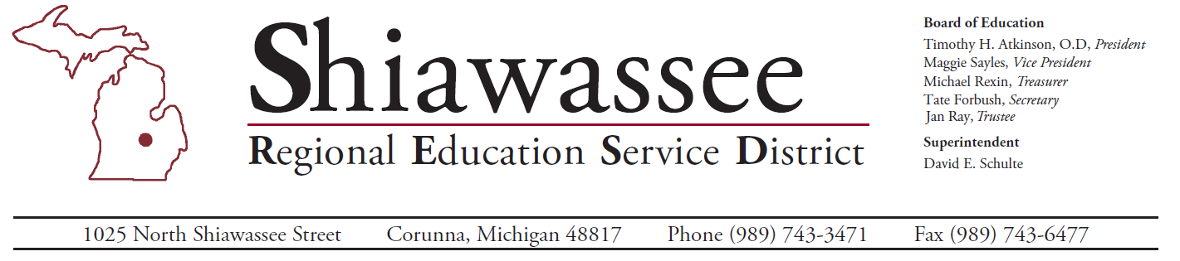

2023 – 2024 CTE Core Performance Indicators
Core Performance Indicator | State Target | Perkins Region 15 | Shiawassee County
1S1 – Graduation Rate | 95.00% | 94.6% | 94.8%
2S1 – Reading/Language Arts | 58.5% | 54.4% | 49.2%
2S2 – Mathematics | 34.5% | 25.5% | 22.7%
2S3 – Science | Not Applicable | 38.5% | 34.9%
3S1 – Placement Rate | 95.0% | 95.4% | 93.3%
4S1 – Non-Traditional | 19.5% | 29.8% | 42.6%
5S1 – Credential Attainment | 7.5% | 16.9% | 8.0%

Our Mission: Provide knowledge driven, research based, direct and collaborative services that support and guide quality learning, innovation and diversity.

