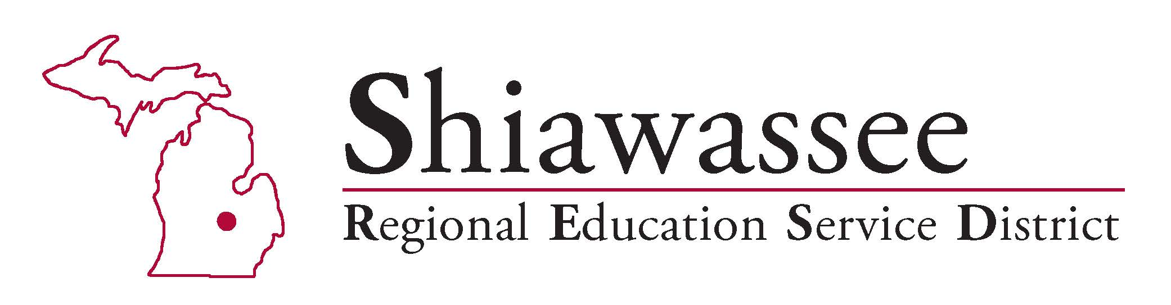

MOCK INTERVIEW STUDENT EVALUATION

- Do you feel the mock interviews were helpful to you? ___ Yes ___ No
Why or why not? _______________________________________________________
______________________________________________________________________

- Do you feel you were prepared for the mock interview? ___ Yes ___ No
If no, what was missing? __________________________________________________
_______________________________________________________________________

- Do you feel you need more information or practice on any of the following areas?
Please check all that apply:
___ Job Applications ___ Job Search ___ Interviewing ___ Resumes
Other__________________________________________________________________

- Please indicate the career or job you are most interested in obtaining after graduating from high school ________________________________________________________

- What suggestions do you have to improve the mock interview process?

________________________________________________________________________

________________________________________________________________________

- Please indicate what education or training will be required to attain this career/job:
_____ Four-Year College
_____ Two year Degree
_____ Technical / Specialized School
_____ Military Training
_____ On the Job Training
Other_________________________________________________________

Thank You for taking time to complete this form

Shiawassee RESD, 1025 N. Shiawassee St., Corunna MI 48817, Phone: (989) 743-3471, Fax: (989) 743-9601

