One Indicator of Poor Learning of Spatial Measurement
The NAEP “Toothpick Problem”

Data available from 1996, 2000, 2003 for 4th and 8th graders*

How long is the toothpick?

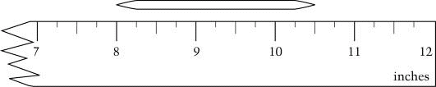

Response Choices:
2 ½ inches
3 ½ inches
8 ½ inches
10 ½ inches

Results:
Percent Correct across three Assessments

 | Percent Correct
Assessment Yr. | 4th Grade | 8th Grade
1996 | 24 | 64
2000 | 25 | 64
2003 | 20* | 58*
* Statistically lower than 1996 and 2000.

Results:

Percent Choosing Each Response
(4th Grade, 2003 only)

Response Choice | Percent Responding
2 ½ inches | 20
10 ½ inches | 14
3 ½ inches | 23
Other | 42
Omitted | 2

Percent Choosing Each Response
(8th Grade, 2003 only)

Response Choice | Percent Responding
2 ½ inches | 58
3 ½ inches | 20
8 ½ inches | 7
10 ½ inches | 13

*Data from the National Center for Education Statistics

