1. Log into EdPlan/EasyIEP
2. Select Student
3. Select Parents Tab
4. Select Add new parent/guardian

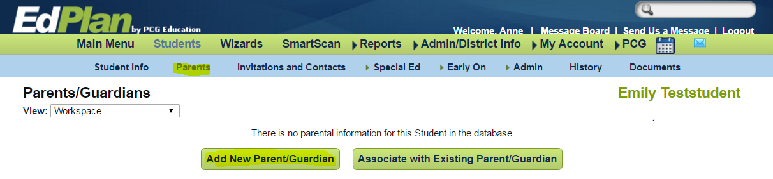
5 Add new parent
4 Parents Tab

5. New window opens. Add information.

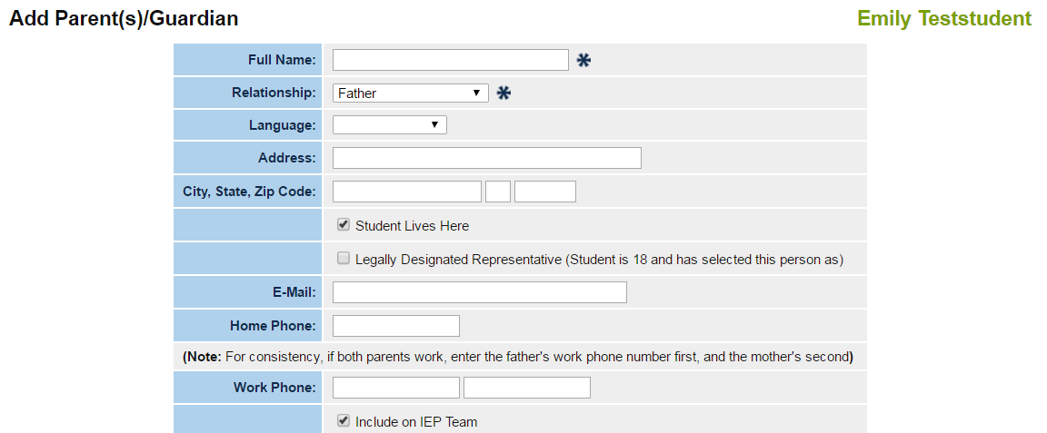

6. To document Transition Student invitation. (Note: If student is 18, he/she should receive his/her personal invitation.)
a. In Full Name section add both parent and student names.
Ex. Mrs. Jen Test and Emily Test.
b. In Relationship section: choose Parent(s) and Student.

7. Check “student lives here”. Check “Include on IEP team”. This address will appear on the IEP and on the invite.

8. Select update the database.

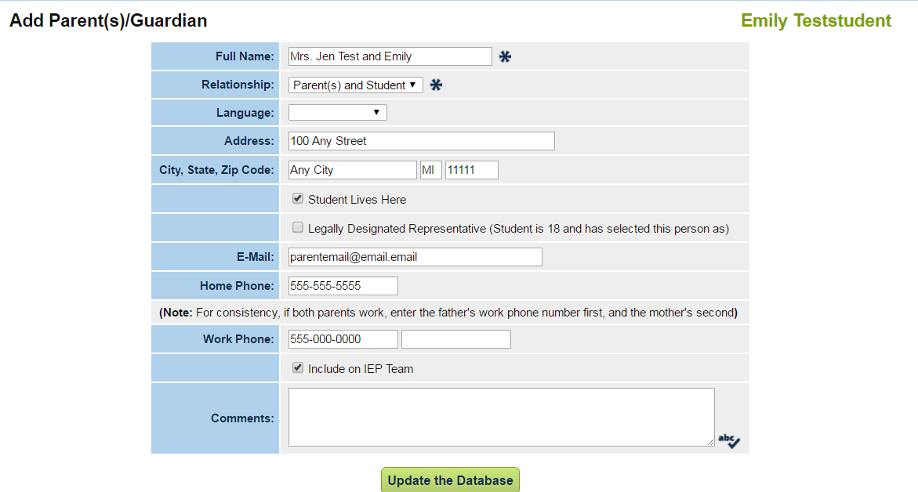
7 Student Lives here
6b Parent(s) and Student Relationship
6a Parents and Student Name
8 Update Database

9. This is how it will appear when completed. The names will print on the IEP invitation as it appears below. Information may be modified by selecting DETAILS on the far right.

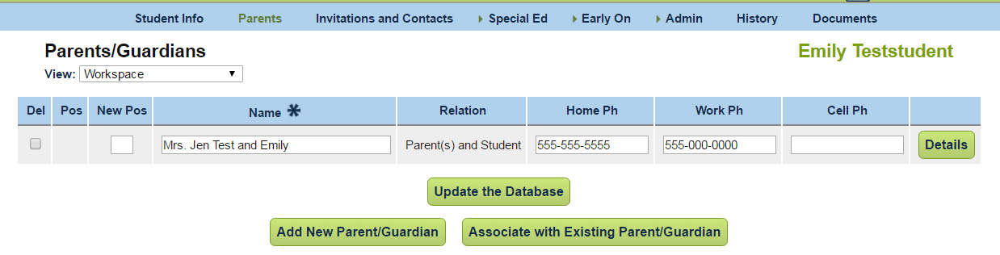

10. Note: A student may be added separately by adding new parent/guardian (see below).
a. Put student’s name in Full Name section.
b. In Relationship section, choose either: “student” or “self”.
c. Complete section and update the database.

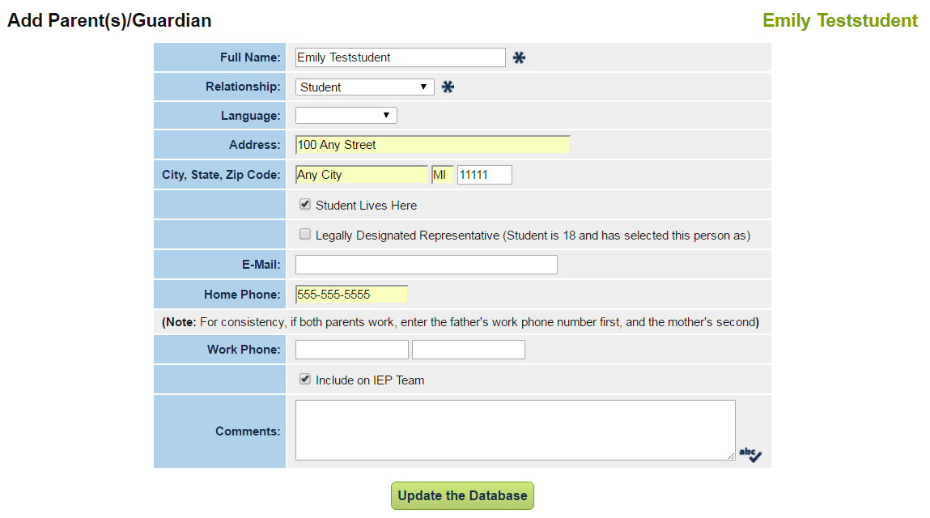
Add student name
Update the database
Choose Student or Self

11. Updated view of the recently added student address information. This information may be modified by selecting DETAILS on the far right.

When creating an invitation, Emily is now available to receive her own invitation.

