1. Log into EdPlan
2. Select Student
3. Select Parent Tab
a. If NO parent information has been entered – Refer to “Adding Parent and Transition Student How To”
b. If information has been previously entered and a change in personal information is needed follow the directions below.

# 3 Parent Tab

4. A table will be displayed of the parents/transition student previously entered.

5. At the right side of the table select “Details”.

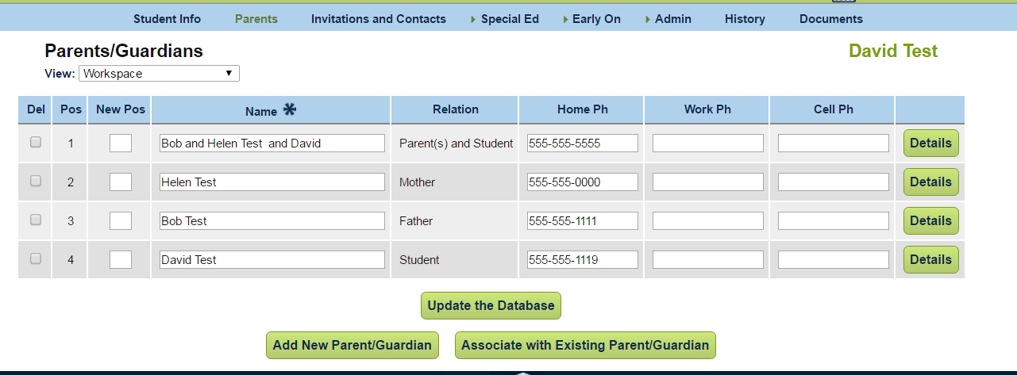
# 4 Table
# 5 Details

6. Parent Information will appear. A. Make changes. B. Update the Database.

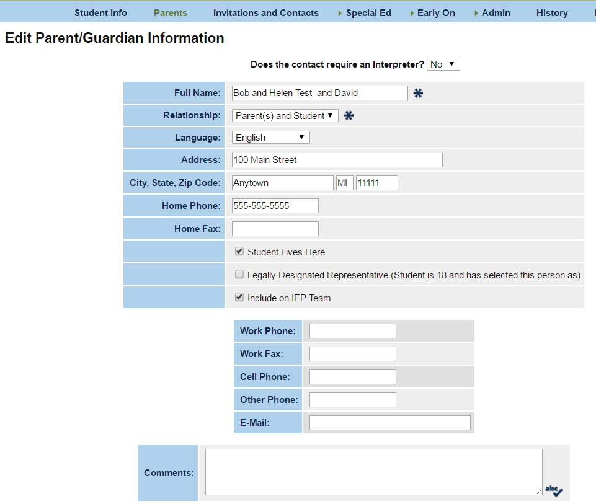
# 6A Parent Info

#6B Update the Database

# 7 Update database

