- Log into EdPlan/EasyIEP
- Select Student
- Select Documents

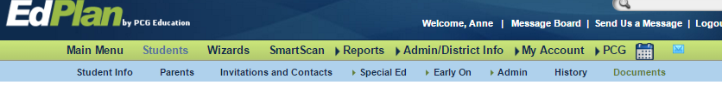

4. New window appears. Document folder is open. Student documents at the bottom.

5. Special Education tab.

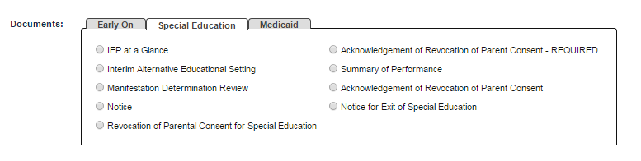
6. Early On tab.

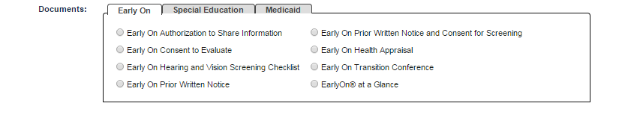
7. Medicaid tab.

