- Log in to EdPlan
- Select Wizards from toolbar
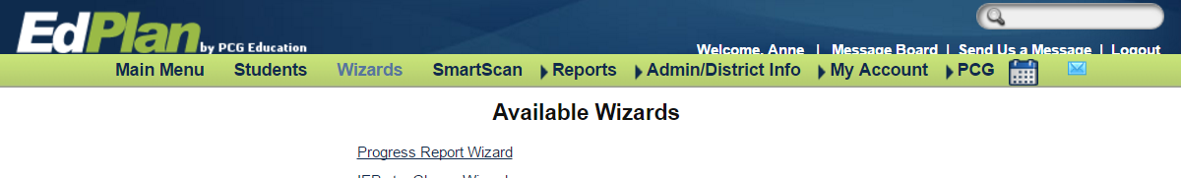
2. Wizards
- Select Progress Report Wizard

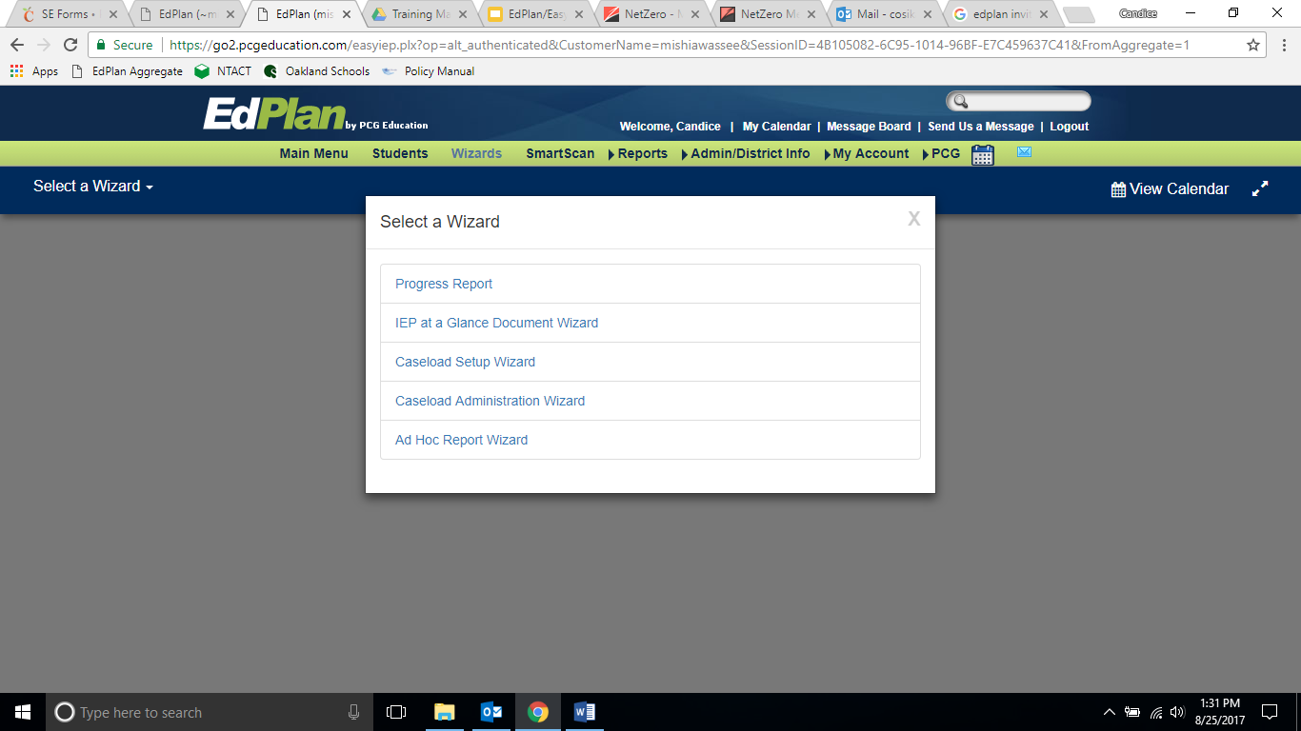
3. Progress Report Wizard

- After selecting Progress Report Wizard, a new window opens. See below snapshot.
- Select the month in the Reporting Period
- Select Students who will need a progress report
- Select “Continue”
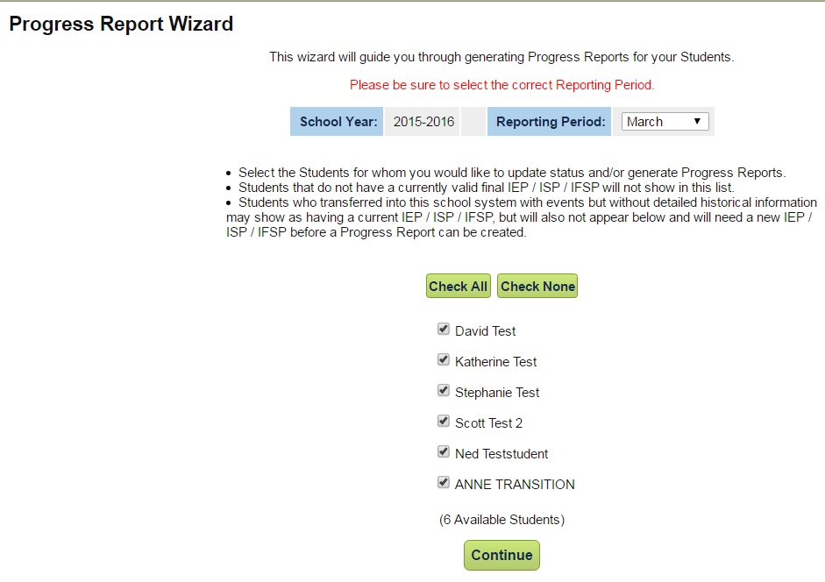
5. Reporting Period
6. Select Students
7. Continue
- The Progress Report will be generated.
- Choose from dropdown menu in Status.
- Add narrative, which should include data.
- If Starting % and Target % was added to the IEP, then complete the Current % to fill in the graph. The graph will be produced on the progress report.
- Person who updated and date of the update will appear in the final column.
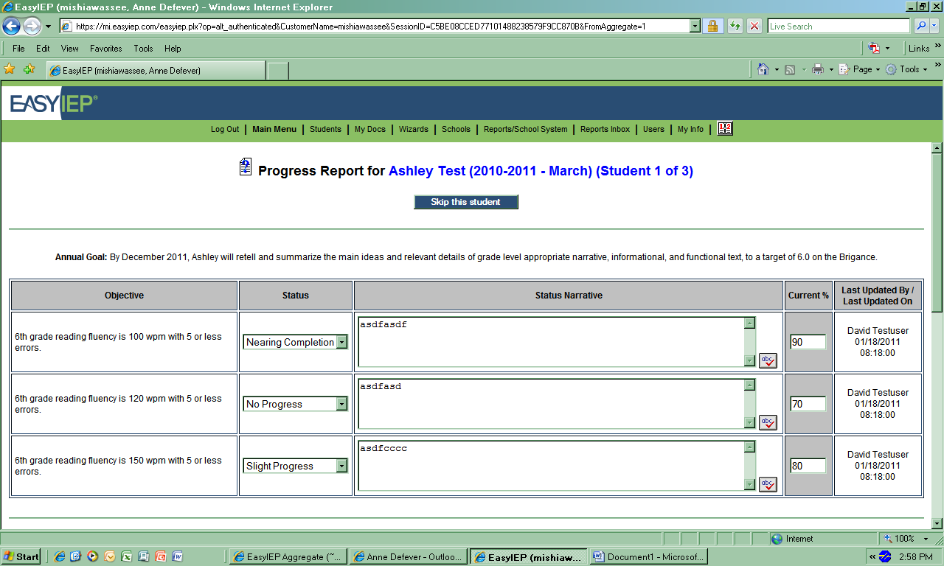
12

11

10

9

- At the bottom of the progress report page choose one of the selections:
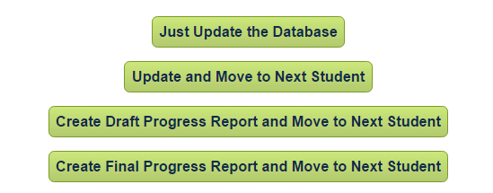
13

- After all progress reports have been created for a caseload, select MAIN MENU.
- Go to a. MY ACCOUNT, select b. MY DOCS from the dropdown.
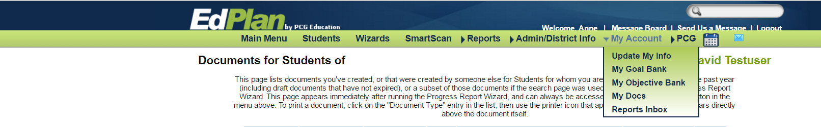
15a
14
15b

- A list of the most recent documents will appear. Check student reports for printing. Go to bottom of page and select VIEW DOCUMENT BATCH.

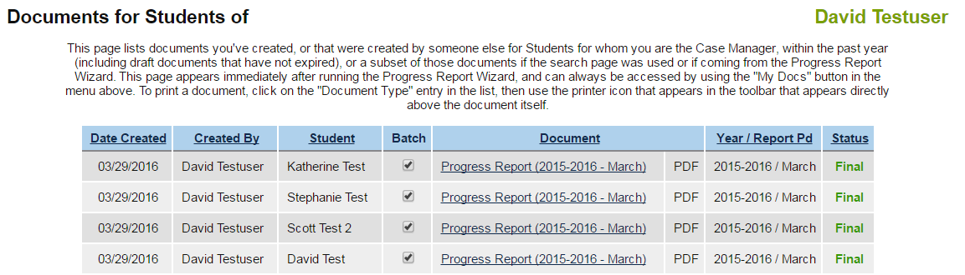

- The documents selected will appear as a PDF. The case manager will be able to print all the documents at the same time. In the snapshot above, 4 student’s progress notes were selected. Notice in the example below there are 6 pages available to print. This prevents the case manager from having to print each document from the individual student’s document folder. In this example, the printer icon is in the upper right hand corner.
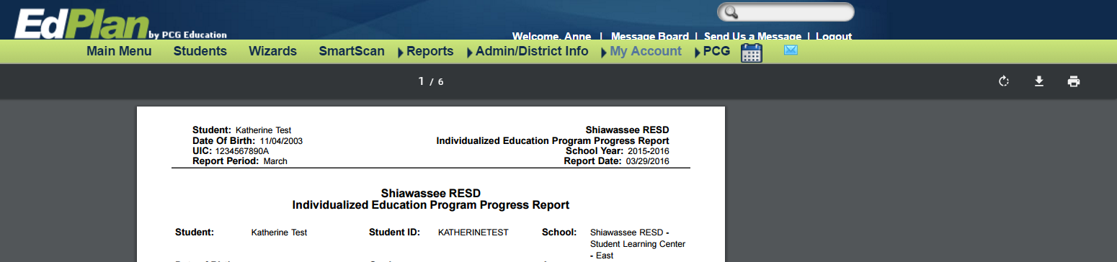

Another way:

- A case manager could go into an individual student’s document folder and print the progress report created.

