1. Log into EdPlan/EasyIEP
2. Select School (If you have multiple schools listed.)
3. Select Student
4. Select: Student Information tab
5. Enter required information *
(UIC Number is “Unique Identification Code” through MSDS.)
6. Case Managers have ability to change the Length of the School Week
7. Enter Medicaid
8. Enter County of Residence
9. Update the database

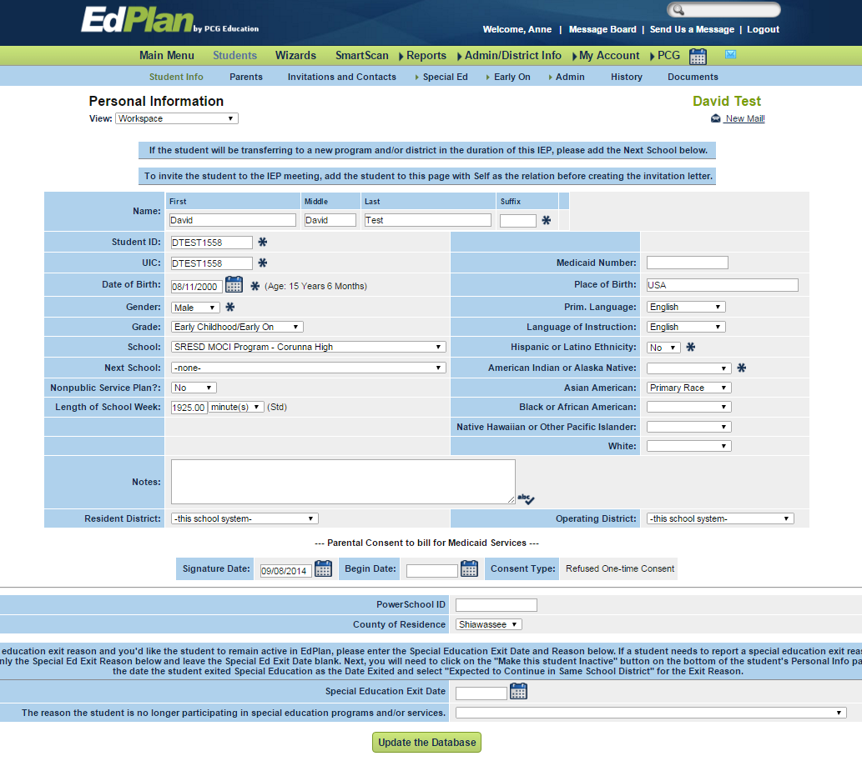
UIC
Min/week
Update
Medicaid Entry
Ethnicity
Race
County

